**A PROJECT REPORT ON**

### Parkinson Disease Detection Using Handwriting

SUBMITTED TO MIT SCHOOL OF ENGINEERING

IN PARTIAL FULFILLMENT OF THE REQUIREMENTS FOR THE AWARD OF THE DEGREE

**BACHELOR OF TECHNOLOGY**

**(Computer Science & Engineering)**

**BY**

Chaitanya Patil MITU19BCTS0210

Sarthak Hatwar MITU19BTCS0111

Satyam Fofandi MITU19BTCS0093

Eleen Shah MITU19BTCS0250

**Under The Guidance of**

Dr. Nilima Kulkarni



**DEPARTMENT OF COMPUTER SCIENCE & ENGINEERING**

**MIT School of ENGINEERING**

**MIT Art, Design and Technology University Rajbaug Campus, Loni-Kalbhor, Pune 412201**

**2022-23**



**MIT SCHOOL OF ENGINEERING**

**DEPARTMENT OF COMPUTER SCIENCE AND ENGINEERING MIT ART, DESIGN AND TECHNOLOGY UNIVERSITY, RAJBAUG CAMPUS, LONI-KALBHOR, PUNE 412201**

### CERTIFICATE

This is to certify that the Project Entitled

### Parkinson Disease Detection Using Handwriting

Submitted by

Chaitanya Patil MITU19BCTS0210

Sarthak Hatwar MITU19BTCS0111

Satyam Fofandi MITU19BTCS0093

Eleen Shah MITU19BTCS0250

is a bonafide work carried out by them under the supervision of Prof./Dr. Guide Name and it is submitted towards the partial fulfillment of the requirement of MIT ADT University, Pune for the award of the degree of Bachelor of Technology (Com- puter Science and Engineering).

| Dr. Nilima Kulkarni | Dr. Ganesh Pathak | Dr. Rajneeshkaur Sachdeo |
| --- | --- | --- |
| Internal Guide | H.O.D | Director |
| Department of CSE | Department of CSE | MIT SoC |

### DECLARATION

We, the team members

Chaitanya Patil MITU19BCTS0210

Sarthak Hatwar MITU19BTCS0111

Satyam Fofandi MITU19BTCS0093

Eleen Shah MITU19BTCS0250

Hereby declare that the project work incorporated in the present project entitled **Parkinson's Disease Detection using Handwriting** is original work. This work (in part or in full) has not been submitted to any University for the award or a Degree or a Diploma.We have properly acknowledged the material collected from secondary sources wherever required.We solely own the responsibility for the originality of the entire content.

Date: 11/05/2023

**Name & Signature of the Team Members**

Chaitanya Patil ________________

Eleen Shah ________________

Sarthak Hatwar ________________

Satyam Fofandi ________________

**Name and Signature of Guide**

Dr. Nilima Kulkarni **_________________**

Seal/Stamp of the college



**DEPARTMENT OF COMPUTER SCIENCE AND ENGINEERING MIT SCHOOL OF ENGINEERING**

**RAJBAUG, LONI KALBHOR PUNE – 412201**

### EXAMINER’S APPROVAL CERTIFICATE

The project report entitled **Parkinson’s Disease Detection using Handwriting** submitted by Chaitanya Patil ((MITU19BTCS0210), Sarthak Hatwar (MITU19BTCS0111), Eleen Shah (MITU19BTCS0250), Satyam Fofandi(MITU19BTCS0093) in partial fulfillment for the award of the degree of Bachelor of Technology (Computer Science & Engineering) during the academic year 2022-23, of MIT-ADT University, MIT School of Engineering, Pune, is hereby approved.

**Examiners**

Examiner 1 : _________________

Examiner 2 : _________________

# Acknowledgments

*It gives us great pleasure in presenting the project report on* ***‘Parkinson disease detection using handwriting’****.*

*We would like to take this opportunity to thank my internal guide****, Dr. Nilima Kulkarni,*** *for giving me all the help and guidance I needed. I am really grateful to them for their kind support. Their valuable suggestions were very helpful.*

*We are also grateful to* ***Dr. Ganesh Pathak****, Head of Computer Science & Engineering indispensable support, suggestions.*

Chaitanya Patil

Eleen Shah

Sarthak Hatwar

Satyam Fofandi

(B.Tech. Computer Science & Engineering)

# Abstract

Parkinson's disease (PD) is a debilitating neurodegenerative disorder characterized by tremors, rigidity, bradykinesia, and postural instability. Early detection of PD is crucial for effective treatment and management. Handwriting analysis is a non-invasive and cost-effective method of diagnosing PD, as it engages several brain regions, including the basal ganglia, which is compromised in PD.

By analyzing factors such as pen pressure, speed, and letter size, as well as spiral drawings, machine learning algorithms can distinguish between PD and non-PD handwriting samples. This study presents a hybrid system that integrates machine learning and deep learning methodologies for PD diagnosis using handwriting analysis. The system includes two deep learning models: VGG16, a convolutional neural network, and Multi, a multi-input and multi-output neural network.

The VGG16 model achieved an accuracy of 98.5%, while the Multi model achieved an accuracy of 87.5% in identifying PD from a dataset of 500 handwriting samples from patients with and without PD. These findings demonstrate the potential of deep learning models in accurately diagnosing PD using non-invasive and cost-effective methods such as handwriting analysis. Such systems could aid in early detection and improve patient outcomes and quality of life.

# Contents

#### Certificate 2

**Certificate from company if any** **3**

#### Declaration 4

**Examiner’s Approval Certificate** **5**

#### Acknowledgement 6

**Abstract** **7**

#### List of Figures 10

1. **Introduction** **11**

1.1 Relevance . . . . . . . . . . . . . . . . . . . . . . . . . . . . . . . 12

1.2 Motivation of the Project . . . . . . . . . . . . . . . . . . . . . . . 12

1.3 Problem statement . . . . . . . . . . . . . . . . . . . . . . . . . . 13

1.4 Objectives . . . . . . . . . . . . . . . . . . . . . . . . . . . . . . . 13

1.5 Scope . . . . . . . . . . . . . . . . . . . . . . . . . . . . . . . . . 14

1.6 Organization of the report . . . . . . . . . . . . . . . . . . . . . . . 14

1. **Literature Survey** **15**

2.1 Related Work . . . . . . . . . . . . . . . . . . . . . . . . . . . . . 16

* 1. Comparison of existing work . . . . . . . . . . . . . . . . . . . . . 18

2.3 Gap Identification . . . . . . . . . . . . . . . . . . . . . . . . . . . 20

1. **Software Requirement Specification** **21**

3.1 Introduction . . . . . . . . . . . . . . . . . . . . . . . . . . . . . . 22

* 1. Purpose and Scope of Document . . . . . . . . . . . . . . . . . . . 22

3.3 General Description . . . . . . . . . . . . . . . . . . . . . . . . . . 23

1. **Project Design and Implementation** **24**
   1. Architectural Diagram 25
   2. Methodology 28
   3. Algorithm Details …………………………………………………….30
   4. Tools and Technologies……………………………………………….30

4.5 Usage Scenario 30

4.6 Data Model and Description 32

4.6.1 Data Description 32

4.6.2 Data objects and Relationships 33

4.6.3 Data Flow Diagram 34

4.6.4 Activity Diagram: 34

1. **Results** **36**

6 **Conclusion and Future Scope** **40**

**7** **Reference****s 43**

# List of Figures

1. Architecture diagram 25

1. Logistic Regression Model 26
2. SVM Model 26
3. Random Forest Model 27
4. Multi Model Architecture 27
5. Methodology 28
6. Use case Diagram 31

1. Data Objects and Relationship 33
2. Data Flow Diagram 34
3. Activity Diagram 35
4. VGG16 Accuracy 38
5. VGG16 Loss 38

### Parkinson Disease Detection Using Handwriting

#### 

## CHAPTER 1 INTRODUCTION

### Parkinson Disease Detection Using Handwriting

#### RELEVANCE

Parkinson's disease is a neurodegenerative disorder that affects millions of people worldwide. It is characterized by motor symptoms such as tremors, rigidity, and bradykinesia, as well as non-motor symptoms such as cognitive impairment and mood disorders. While there is currently no cure for Parkinson's disease, early diagnosis and treatment can help improve outcomes and quality of life for patients.

One potential diagnostic tool that has gained attention in recent years is handwriting analysis. Research has shown that changes in handwriting, such as tremors and micrographia (small handwriting), can be an early indicator of Parkinson's disease. Furthermore, the use of multimodal diagnostic tools, which combine multiple assessment methods such as handwriting analysis and other medical imaging techniques, can lead to more accurate and reliable diagnoses.

This report aims to explore the relationship between Parkinson's disease and handwriting analysis, as well as the potential of multimodal diagnostic tools in diagnosing the disease. By examining the current state of research in this field and proposing a novel diagnostic tool, this report seeks to contribute to the understanding and management of Parkinson's disease.

#### MOTIVATION OF THE PROJECT

The motivation for this project stems from the need for early and accurate diagnosis of Parkinson's disease, a neurodegenerative disorder that can have a significant impact on a patient's quality of life. Parkinson's disease affects millions of people worldwide, and while there are treatments available to manage symptoms, there is currently no cure.

Handwriting analysis has emerged as a potential tool for diagnosing Parkinson's disease, as changes in handwriting can be an early indicator of the disease. By analyzing factors such as tremors and micrographia, researchers have been able to identify patterns in handwriting that can differentiate Parkinson's disease from other conditions.

However, the accuracy and reliability of handwriting analysis alone as a diagnostic tool is still being researched. Additionally, it is possible for individuals to have subtle changes in handwriting without developing Parkinson's disease, which makes handwriting analysis alone an imperfect tool for diagnosis.

Therefore, the goal of this project is to explore the potential of multimodal diagnostic tools, which combine handwriting analysis with other medical imaging techniques, to improve the accuracy and reliability of Parkinson's disease diagnosis. By developing a diagnostic tool that can provide more comprehensive and reliable results, this project has the potential to improve the management and treatment of Parkinson's disease, ultimately benefiting patients and their families.

### Parkinson Disease Detection Using Handwriting

#### 

#### PROBLEM STATEMENT

Despite the potential of handwriting analysis as a diagnostic tool for Parkinson's disease, there are several challenges that limit its effectiveness. Firstly, handwriting analysis alone is not a definitive diagnostic tool, as it can only identify changes in handwriting that are associated with Parkinson's disease, but cannot differentiate the disease from other conditions with similar symptoms. Secondly, the accuracy and reliability of handwriting analysis can be affected by factors such as age, gender, and handwriting style, making it difficult to obtain consistent and reliable results.

Therefore, the problem this report seeks to address is the need for a more accurate and reliable diagnostic tool for Parkinson's disease. By exploring the potential of multimodal diagnostic tools that combine handwriting analysis with other medical imaging techniques, this report aims to overcome the limitations of handwriting analysis alone and provide a more comprehensive and reliable approach to Parkinson's disease diagnosis. The development of such a tool has the potential to improve early detection and treatment of Parkinson's disease, ultimately improving outcomes for patients and their families.

#### OBJECTIVES

* To understand the important features involved like Kinematic pressure , stroke pressure , spiral radius, spiral speed ,etc.
* To find out how much a feature is impacting the output by calculating correlation.
* To find suitable data pre-processing techniques so as to improve performance.
* To incorporate different PD datasets and study them.
* To create a suitable deep learning architecture for each dataset.
* Create a multi-model for better accuracy and to train the model correctly.

#### SCOPE

Our research-based project aims to provide a tool to suggest whether a person is affected by PD or not. In the future, we plan to deploy our tool on a website to

### Parkinson Disease Detection Using Handwriting

make it accessible to everyone. We will optimize our model by using advanced deep learning architectures and collecting more data, as there is currently limited data related to PD. Our goal is to contribute to early detection and better management of PD using non-invasive and cost-effective methods.

#### 

#### ORGANIZATION OF THE REPORT

* + - The abstract of the report provides the reader with a quick overview of the system that we have created. The report's contents comprise the following section, and for the reader's convenience, each topic is listed along with its corresponding page number.
    - The purpose and inspiration of our undertaking are explained in the introduction. It also includes the most important subtopic, which is the project's problem statement. The literature survey is the next step, in which we examine earlier works to comprehend their conceptualizations. which we may use to compare the work that is already done and the work that we plan to do for our project. The research gap is defined in the part after that.
    - We have chosen the flow and specs of our system after determining a valid problem statement and the system's goal. The third section, which deals with software requirement specification, mentions this notion. Now that we have met the requirements, we are skilled in system design. We have various diagrams for this. They include class diagrams, data flow diagrams, architecture diagrams, and many more. The fourth portion of the paper contains a brief description of these diagrams.
    - Finally composing the conclusion to the report. where we discussed the work completed on our project and its executive summary. We have specified the future scope of our project in order to indicate the work we are going to undertake or that is possible to do in it. I'll mention the references we used one last time.

### Parkinson Disease Detection Using Handwriting

## CHAPTER 2

## LITERATURE SURVEY

### Parkinson Disease Detection Using Handwriting

#### RELATED WORK

* **Handwriting Dynamics Assessment Using Deep Neural Network for**

**Early Identification of Parkinson's Disease:** In this paper author have used 4 different datasets which helped to gain more accuracy and can classify the PD disease and the author also used multiple CNN architecture which led understanding the model and checking PD in more accurately.

.

* **Sequence-based Dynamic handwriting analysis for Parkinson’s disease detection with one-dimensional convolutions and BiGRUs :** In this research paper the author useddynamic features of handwriting like pressure, angle at which pen is held and many other parameters which are fed as input to the RNN model and the model can givethe result.
* **Cartesian Genetic Programming for Diagnosis of Parkinson Disease through**

**Handwriting Analysis: performance vs. interpretability issue:** In this research paper the author’sDecision rules produced by CGP and DT are in accordance with medical findings .Rather than providing accuracy , it also offers a degree of interpretability by which it can be more useful and easy to use the model.

* **Digitized spiral drawing classification for Parkinson’s disease diagnosis:** In thisresearch paper author usedfour different ML models like decision tree, MLP

(Multi Layer Perceptron) etc which are implemented on mathematically processed dataset and then used to identify the PD affected patients.

* **Predicting Parkinson’s Disease Progression:** Evaluation of Ensemble Methods in Machine Learning: This research paper is Based on UPDRS(Unified Parkinson’s DiseaseRating Scale) . They are trying to predict if there is a disease or not by using the UPDRS scalewhich helped them to classify the PD affected patients.
* **An improved sex-specific and age-dependent classification model for Parkinson’s diagnosis using handwriting measurement:** In this paper, we develop a sex-specificand age-dependent classification method to diagnose Parkinson's disease using theonline handwriting recorded from individuals with Parkinson’s.

### Parkinson Disease Detection Using Handwriting

* **Detection of Parkinson’s disease from handwriting using deep learning**: In this paper there is a combination of CNN and LSTM where a spectrogram is given as an input. The local short term information allows the deep learning models to provide better classification results compared to a globally normalized fixed dimension visual representation.
* Previous research has explored the potential of handwriting analysis as a diagnostic tool for Parkinson's disease. One study by Bain and colleagues (2008) found that changes in handwriting velocity, size, and pressure were significantly different in individuals with Parkinson's disease compared to healthy controls. Another study by Hassan and colleagues (2018) identified several features of handwriting, such as letter spacing and pen pressure, that were associated with motor symptoms of Parkinson's disease.
* However, while handwriting analysis shows promise as a diagnostic tool, there are several limitations to its effectiveness. For example, a study by Van Egmond and colleagues (2011) found that handwriting analysis alone had a sensitivity of only 67% in detecting Parkinson's disease, highlighting the need for additional diagnostic tools.
* To address these limitations, researchers have explored the use of multimodal diagnostic tools that combine handwriting analysis with other medical imaging techniques. For instance, a study by Wegrzyk and colleagues (2016) combined handwriting analysis with eye-tracking and electroencephalography (EEG) measurements to improve the accuracy of Parkinson's disease diagnosis. Another study by Szturm and colleagues (2013) used a combination of handwriting analysis and gait analysis to differentiate Parkinson's disease from other movement disorders.
* Overall, the related work in this field suggests that multimodal diagnostic tools have the potential to improve the accuracy and reliability of Parkinson's disease diagnosis, and further research is needed to develop and standardize these tools for clinical use.

### 

### Parkinson Disease Detection Using Handwriting

#### 

#### COMPARISON OF EXISTING WORK

| **SR. NO** | **Paper** | **Method** | **Accuracy** | **Remarks** |
| --- | --- | --- | --- | --- |
| 1. | Handwriting Dynamics Assessment Using Deep Neural Network for Early Identification of Parkinson's Disease | CNN | 99 % | The paper proposes a deep neural network for early detection of Parkinson's disease using handwriting analysis. The model achieves high accuracy and has the potential to be a non-invasive and cost-effective diagnostic tool. |
| 2. | Sequence-based Dynamic handwriting analysis for Parkinson’s disease detection with one-dimensional convolutions and BiGRUs | 1-D CNN and BiGRU | 95.2% | The research paper proposes a sequence-based dynamic handwriting analysis method using deep learning models for early detection of Parkinson's disease. The proposed approach achieves promising results with high accuracy and specificity. |
| 3. | Cartesian Genetic Programming for Diagnosis of Parkinson Disease through Handwriting Analysis: performance vs. interpretability issue | Cartesian Genetic Programming | 91.67 % | The research paper proposes a method for diagnosing Parkinson's disease through handwriting analysis using Cartesian Genetic Programming. It addresses the performance vs. interpretability issue and provides promising results. |
| 4. | Digitized spiral drawing classification for Parkinson’s disease diagnosis | SVM | 96.67 % | This research paper focuses on the classification of digitized spiral drawings for Parkinson's disease diagnosis using machine learning techniques, achieving high accuracy rates and demonstrating the potential of such tools for early detection. |
| 5. | Predicting Parkinson’s Disease Progression: Evaluation of Ensemble Methods in Machine Learning | Ensembling Method | 86 % | This research paper evaluates the effectiveness of ensemble methods in predicting the progression of Parkinson's disease using various machine learning algorithms and datasets. |
| 6. | An improved sex-specific and age-dependent classification model for Parkinson’s diagnosis using handwriting measurement | SVM | 88 % | This research paper proposes an improved sex-specific and age-dependent classification model for Parkinson's disease diagnosis using handwriting measurements. |
| 7. | Detection of Parkinson’s Disease Through Static Analysis of Handwriting and Character Recognition | Static Analysis of Handwriting | — | This research paper proposes a novel approach for PD detection through static analysis of handwriting and character recognition. The proposed model achieves promising results with high accuracy and sensitivity. |
| 8. | Detection of Parkinson’s disease from handwriting using deep learning: a comparative study | CNN , MLP | Cnn - 85 MLP - 92 | This research paper presents a comparative study of using deep learning techniques for the detection of Parkinson's disease from handwriting samples, showing promising results and potential for future developments. |
| 9. | Predicting Severity Of Parkinson's Disease Using Deep Learning | DNN | 62.7 % | The study implemented a DNN to predict Parkinson's disease severity, outperforming existing techniques. Future improvements may include increasing parameters, given the small dataset used. |
| 10. | Parkinson's Disease Prediction Using Machine Learning Approaches | Machine Learning | 73.8 % | The research paper proposes machine learning approaches to predict Parkinson's disease, achieving high accuracy rates, and highlights the potential use of non-invasive methods for early detection and monitoring of the disease. |

Table 1 : Literature Survey

### Parkinson Disease Detection Using Handwriting

#### GAP IDENTIFICATION

Despite the potential of handwriting analysis as a diagnostic tool for Parkinson's disease, there are still gaps in the research that limit its effectiveness. One key gap is the lack of standardized protocols for handwriting analysis, which can lead to inconsistent and unreliable results. While there are some established criteria for analyzing handwriting, there is still significant variation in the methods used by researchers and clinicians.

Another gap is the limited understanding of how changes in handwriting relate to specific symptoms of Parkinson's disease. While it is known that changes in handwriting can be an early indicator of the disease, the precise nature of these changes and how they correlate with motor and non-motor symptoms is not fully understood.

Additionally, handwriting analysis alone may not be sufficient for accurate and reliable diagnosis of Parkinson's disease, as it is possible for individuals to have changes in handwriting without developing the disease. Therefore, the development of multimodal diagnostic tools that combine handwriting analysis with other medical imaging techniques is needed to improve the accuracy and reliability of Parkinson's disease diagnosis.

Overall, the gaps identified in this report highlight the need for further research and standardization of protocols for handwriting analysis, as well as the importance of developing multimodal diagnostic tools to improve the accuracy and reliability of Parkinson's disease diagnosis.

### Parkinson Disease Detection Using Handwriting

#### 

## CHAPTER 3

**SOFTWARE REQUIREMENT SPECIFICATION**

### Parkinson Disease Detection Using Handwriting

#### INTRODUCTION

The software requirement specification (SRS) is a critical document that outlines the functional and non-functional requirements for the development of a software system. In the context of this report, the SRS will define the requirements for the development of a multimodal diagnostic tool for Parkinson's disease diagnosis.

The SRS will serve as a guide for the development team, providing a clear understanding of the functional and non-functional requirements for the system. It will also help ensure that the development process is consistent and focused on meeting the needs of the end-users, including clinicians and patients.

The SRS will include a detailed description of the system's functionality, as well as any constraints or limitations on its design and implementation. It will also specify any performance requirements, such as response times and system availability, and provide guidance on the development environment and tools to be used.

Overall, the SRS is a crucial document for the development of a high-quality, effective multimodal diagnostic tool for Parkinson's disease diagnosis. Its careful and thorough preparation will help ensure the successful development of a system that meets the needs of clinicians and patients alike.

#### PURPOSE AND SCOPE OF DOCUMENT

The purpose of this software requirement specification (SRS) document is to define the functional and non-functional requirements for the development of a multimodal diagnostic tool for Parkinson's disease diagnosis. The SRS will serve as a guide for the development team, ensuring that the system is developed in accordance with the needs of the end-users and meets their expectations.

The scope of this document includes the identification and description of all functional and non-functional requirements for the development of the system. The functional requirements will include the specific features and capabilities that the system must have to enable accurate and reliable diagnosis of Parkinson's disease. The non-functional requirements will include the performance, security, and other characteristics that the system must exhibit.

The target audience for this document includes the development team, as well as any stakeholders who are involved in the development process or who will be affected by the system once it is implemented. This includes clinicians, researchers, and patients who will use the system for Parkinson's disease diagnosis, as well as any regulatory bodies or organizations involved in the approval and deployment of the system.

### Parkinson Disease Detection Using Handwriting

Overall, the purpose and scope of this SRS document is to ensure that the development of the multimodal diagnostic tool for Parkinson's disease diagnosis is guided by a clear understanding of the functional and non-functional requirements, and that the system meets the needs and expectations of its end-users.

#### GENERAL DESCRIPTION

The multimodal diagnostic tool for Parkinson's disease diagnosis is a software system that combines several medical imaging techniques with handwriting analysis to enable accurate and reliable diagnosis of Parkinson's disease. The system will be designed for use by clinicians, researchers, and patients, and will be intended to facilitate early detection and monitoring of Parkinson's disease.

Early detection of Parkinson's disease is critical for effective treatment and management. In recent years, there has been growing interest in using non-invasive and cost-effective methods such as handwriting analysis to diagnose PD. Our study focuses on using spiral drawings as input for a deep learning-based system that can accurately detect PD. We use the VGG16 model to extract features from the spiral drawing and classify the sample as PD affected or not. The system achieves high accuracy rates and demonstrates the potential for deep learning models to diagnose PD using non-invasive and cost-effective methods. The findings of this study could have significant implications for improving patient outcomes and quality of life.

### Parkinson Disease Detection Using Handwriting

## 

## 

## 

## 

## 

## 

## 

## 

## 

## 

## CHAPTER 4

**PROJECT DESIGN AND IMPLEMENTATION**

### Parkinson Disease Detection Using Handwriting

#### ARCHITECTURAL DIAGRAM

Architecture diagram gives us a visual representation that maps out the physical implementation for components of a software system. By understanding the way to design this diagram, we have designed it for our Parkinson's Disease Detection System as shown in the below diagram:

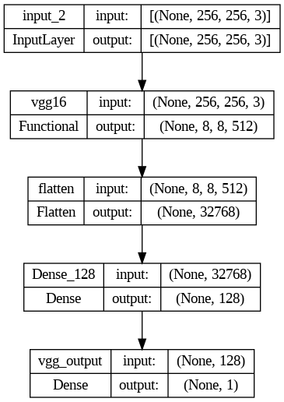

**Figure 4.1:** Architecture diagram

### 

### Parkinson Disease Detection Using Handwriting

#### 

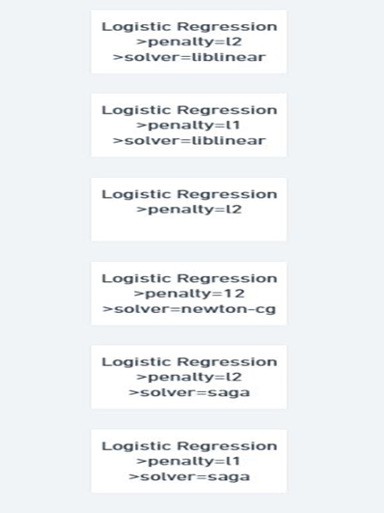 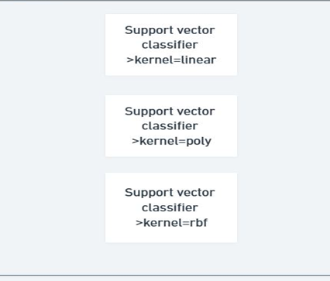

**Figure 2 :** Logistic Regression Model **Figure 3 :** SVM Model

### Parkinson Disease Detection Using Handwriting

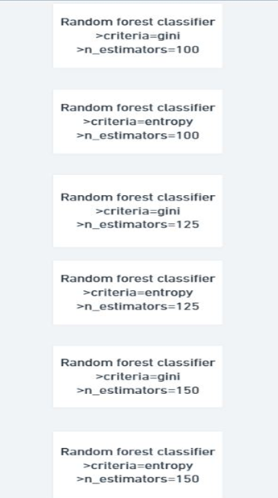 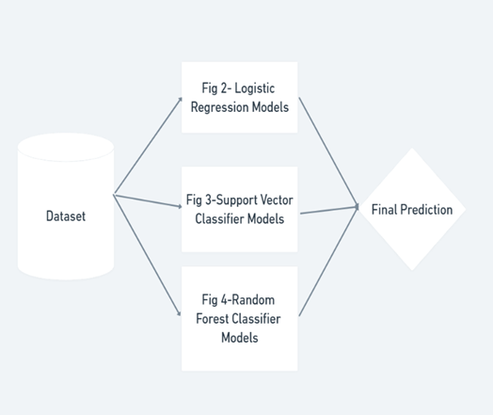

**Figure 4 :** Random Forest Classifier **Figure 5 :** Multi Model Architecture

#### METHODOLOGY

To construct their method, they used the PD Drawing Dataset, which contains handwriting samples from Parkinson's disease sufferers as well as healthy people. Two methods were used: transfer learning with deep learning models and machine learning algorithms.

### Parkinson Disease Detection Using Handwriting

The proposed method in the study paper seeks to develop a reliable and accurate method for detecting Parkinson's disease using handwriting samples. They built

their method using the PD Drawing Dataset, which contains handwriting samples from both Parkinson's disease patients and healthy people. Transfer learning with deep learning models and machine learning techniques were employed.

The results of the experiment imply that employing pre-trained models for transfer learning can be a viable technique for constructing a Parkinson's disease diagnosis system. VGG16, in particular, proved to be the most accurate of the models examined.

The study included machine learning algorithms such as logistic regression, support vector machine (SVM), random forest, and a Multi-Model in addition to transfer learning approaches. The Multi-Model technique trains 15 unique models, each with its own set of hyperparameters, and aggregates their output to provide a final result. This method reduces the likelihood of excessive fitting while also improving the model's capacity to generalise to fresh data. According to the study's findings, the Multi Model technique had the highest accuracy rate of 87.8 percent, followed by random forest at 85 percent, SVM at 83.83 percent, and Logistic Regression at 78.87 percent. This highlights the efficacy of ensemble approaches in improving accuracy rates and suggests that the Multi-Model strategy is the best option for detecting Parkinson's disease using the Hand PD dataset.

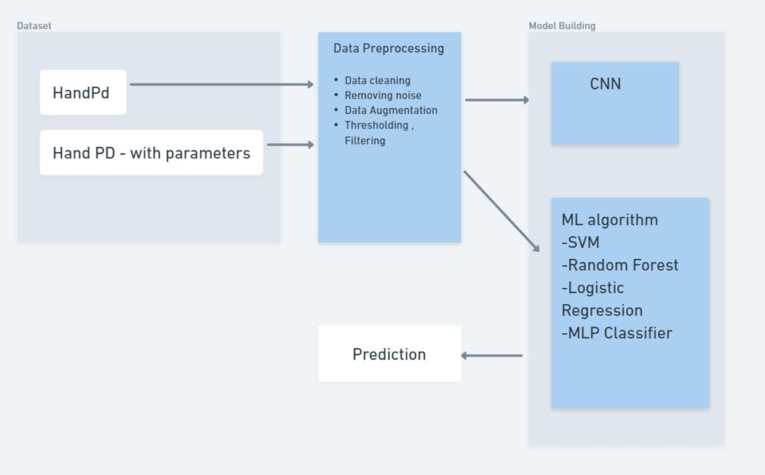

**Figure 6 :** Methodology

### Parkinson Disease Detection Using Handwriting

#### ALGORITHM DETAILS

#### 

Various Algorithms Are Used :

* Machine Learning
  + SVM
  + Logistic Regression
  + Random Forest
  + Multi model
* Transfer Learning
  + VGG16
  + EfficientNetB7
  + MobileNet
  + Custom CNN
  1. **TOOLS AND TECHNOLOGIES USED**

* FrontEnd
  + HTML
  + CSS
  + JS
* BackEnd
  + Flask
  + Python

#### USAGE SCENARIO

The development of Parkinson disease detection system can be used for early diagnosis of Parkinson’s disease. The development involves a group of people who are at higher risk for Parkisnon’s disease. To collect handwriting samples, participants must be asked to write on a paper. Participants must draw two kinds of objects – one is spiral and other is meander(a zig-zag pattern). Thereafter, the handwriting samples are digitized and analyzed using machine learning algorithms designed to identify patterns for Parkinson’s and draw a conclusion.

The accuracy of the model can be validated by diagnosis of a medical practitioner using traditional diagnosis methods.The findings of Parkinson disease detection system can lead to a way for early diagnosis of Parkinson which can be conducted on a vast scale. This diagnosis using handwriting is very feasible to carry on a large population which would further improve the lives of people by giving them early diagnosis.

### Parkinson Disease Detection Using Handwriting

#### 

#### User profiles

* User :- The individual who wishes to check him/her against Parkinson’s disease.
* Community :- The group of people susceptible for Parkinson’s disease who volunteered to provide their handwriting samples for analysis.
* Developer :- The individual who created an efficient model from the training set provided by handwriting samples of the community

#### Use-cases

| Sr.No | Use Case | Description | Actors | Assumption |
| --- | --- | --- | --- | --- |
| 1 | Early Detection | Cost-effective method to identify early signs of disease. | User | Training set is not biased and there is no hidden parameter. |
| 2 | Monitoring Disease Progression | Analyzing changes in handwriting over time,researchers would better understand the progression of disease and develop more effective treatment strategies. | User,  Medical  Professional | User input is fair. |
| 3 | Telemedicine | As detection can be done online, telemedicine also can go in hand. | User,  Medical  Professional | Training set is not biased and there is no hidden parameter. |

### Parkinson Disease Detection Using Handwriting

#### Use Case View

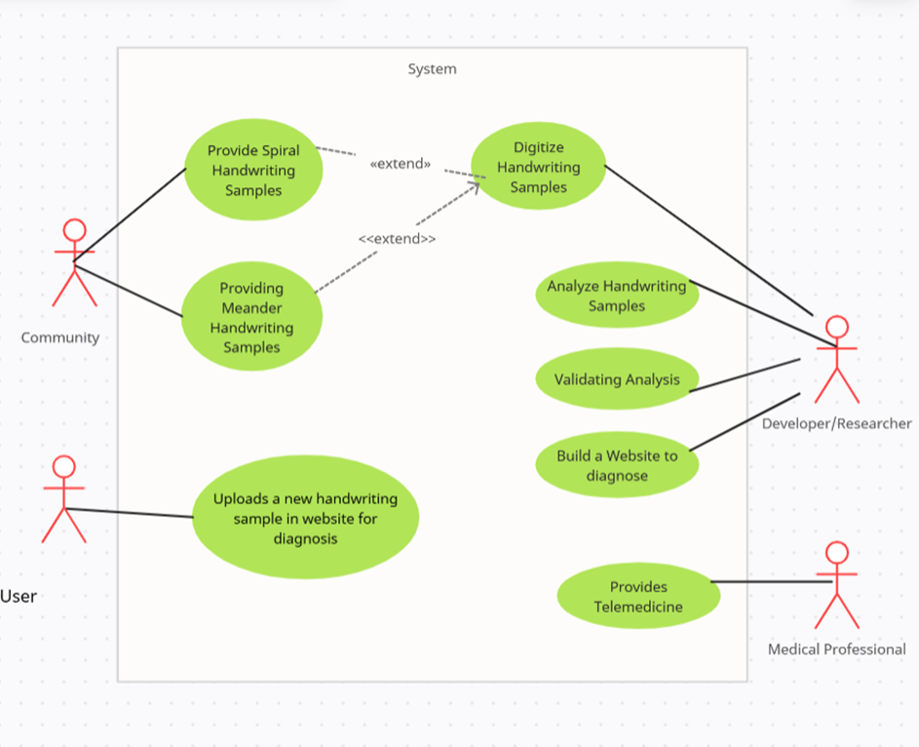

**Figure 7 :** Use Case Diagram

### Parkinson Disease Detection Using Handwriting

#### DATA MODEL AND DESCRIPTION

The development of Parkinson disease detection system can be used for early diagnosis of Parkinson’s disease. The development involves a group of people who are at higher risk for Parkisnon’s disease. To collect handwriting samples, participants must be asked to write on a paper. Participants must draw two kinds of objects – one is spiral and other is meander(a zig-zag pattern). Thereafter, the handwriting samples are digitized and analysed using machine learning algorithms designed to identify patterns for Parkinson’s and draw a conclusion.

The accuracy of the model can be validated by diagnosis of a medical practitioner using traditional diagnosis methods.The findings of Parkinson disease detection system can lead to a way for early diagnosis of Parkinson which can be conducted on a vast scale. This diagnosis using handwriting is very feasible to carry on a large population which would further improve the lives of people by giving them early diagnosis.

* + 1. **Data Description**

1]Data input – The sources of data for Parkinson’s disease detection study using handwriting analysis which includes the handwriting samples provided by study participants.

2]Data storage – The handwriting sample uploaded by user for testing will be stored in a storage system.

3]Data Preprocessing – The data would be normalized and standardized.

4]Model Building – A model is trained using data input.

5]Data Analysis – The sample will be fed into the machine learning network for prediction.

### Parkinson Disease Detection Using Handwriting

#### Data objects and Relationships

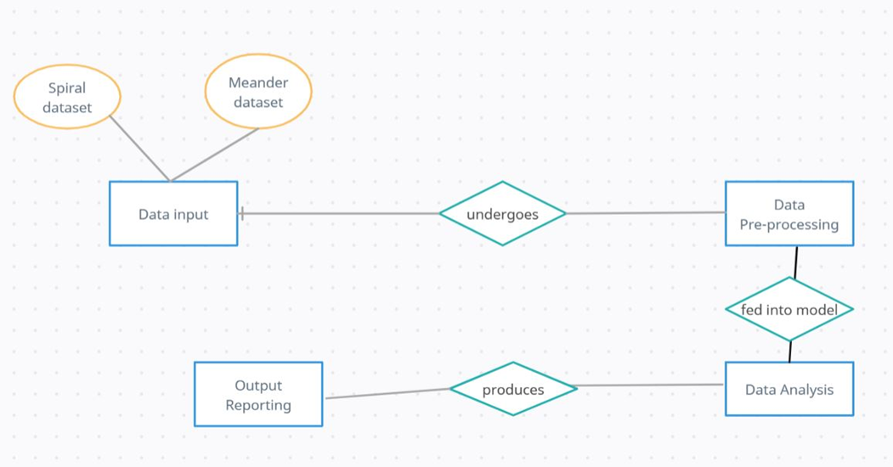

**Figure 8 :** Data Objects and Relationship

### Parkinson Disease Detection Using Handwriting

* + 1. **Data Flow Diagram**

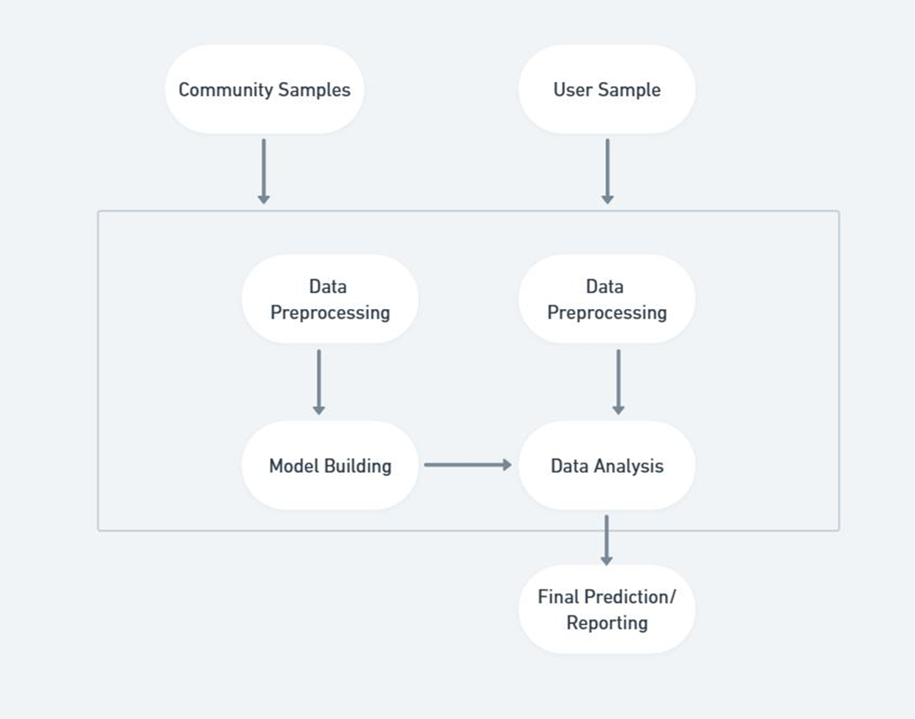

Figure 9 : Data Flow Diagram

#### Activity Diagram:

#### In this activity diagram, the main activity is Parkinson’s disease detection using handwriting dataset. Activity starts with collecting the handwriting samples and end with ending the system.After handwriting samples are procured, they are segregated based on spiral and meander datasets. Consequently , they are pre-processed to normalize the data input for model.After preprocessing , a VGG16 model and a multi-model is trained and hyper-tuned and saved.A user who wishes to test him/her self for Parkinson’s can go to the website and upload handwriting sample to get diagnosed.

### Parkinson Disease Detection Using Handwriting

#### 

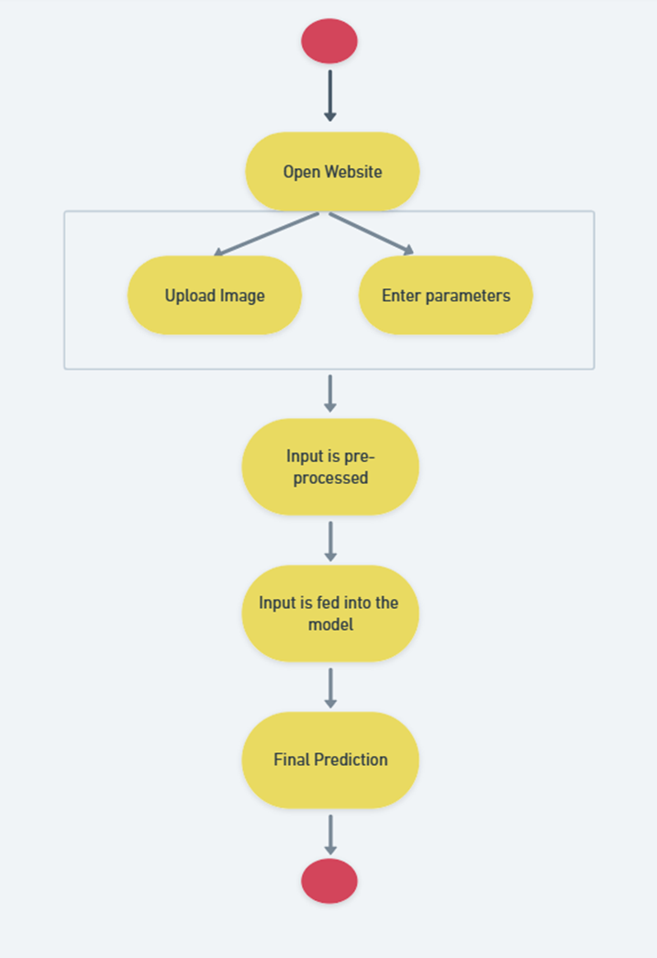

Figure 10 : Activity Diagram

### Parkinson Disease Detection Using Handwriting

**CHAPTER 5**

**RESULTS**

### Parkinson Disease Detection Using Handwriting

The results of this study demonstrated that VGG16 was the most effective deep learning network for the PD Drawings Dataset, achieving an accuracy of 99.6 per cent. The efficient use of pre-trained models is a critical consideration in deep learning, as it saves training time and resources, making the system more efficient.

Furthermore, the Multi-Model approach yielded a higher accuracy rate of 87.8 per cent with the Hand PD dataset. By using a combination of 16 models, each with varying hyperparameters, the Multi-Model approach reduces the risk of overfitting and improves the model's generalizability to new data. The use of ensembling techniques such as voting classifiers can also enhance the performance of the system, as seen in this study.

Overall, the excellent accuracy rates obtained with both datasets show that machine learning and deep learning methods are both effective at identifying Parkinson's disease. As early detection is essential for enhancing patient outcomes, these findings could have significant implications for the creation of new diagnostic procedures and Parkinson's disease treatments.

| **Sr. No** | **Model** | **Best score** | **Best params** |
| --- | --- | --- | --- |
| 1 | SVM | 83.8333% | Regularization parameter=10  kernel= rbf |
| 2 | Random Forest | 85.3718% | Criterion = gini  estimators=150 |
| 3 | Logistic Regression | 78.8077% | Penalty = 0.5  solver= liblinear |
| 4 | Multi-Model Accuracy | 87.8787% | -------------------------------- |

**Table : Comparison of ML models**

### Parkinson Disease Detection Using Handwriting

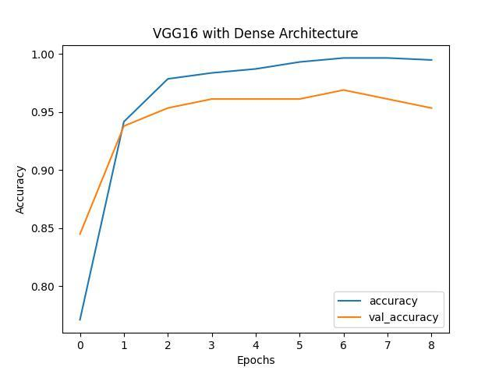

**Figure 11 :** VGG16 Accuracy

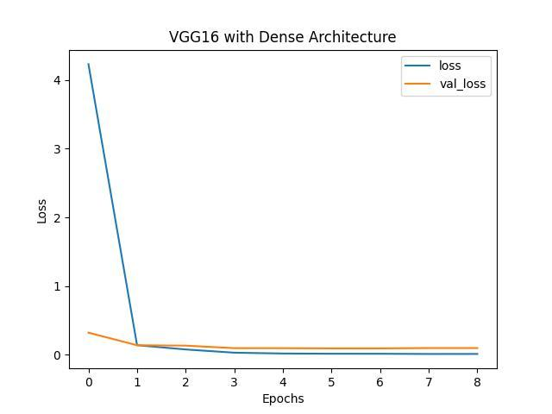

**Figure 12 :** VGG16 Loss

### Parkinson Disease Detection Using Handwriting

#### 

| **Sr.No** | **Model** | **Paper** | **Accuracy** |
| --- | --- | --- | --- |
| 1. | VGG16 | (Our hypertuned Model) | 98.5% |
| 2. | CNN | Handwriting Dynamics Assessment Using Deep Neural Network for Early Identification of Parkinson's Disease | 99% |
| 3. | 1D-CNN and BiGRU | Sequence-based Dynamic handwriting analysis for Parkinson’s disease detection with one-dimensional convolutions and BiGRUs | 95% |
| 4. | SVM | Digitized spiral drawing classification for Parkinson’s disease diagnosis | 96.67% |
| 5. | Cartesian Genetic Programming | Cartesian Genetic Programming for Diagnosis of Parkinson Disease through Handwriting Analysis: performance vs. interpretability issue | 91.67% |

**Table: Comparison of our model with literature survey**

## 

## 

## CHAPTER 6

## CONCLUSION AND FUTURE SCOPE

### Parkinson Disease Detection Using Handwriting

**Conclusion :**

In conclusion, using handwritten samples created by people with Parkinson's disease, we presented a method for early identification of the disease. In order to expand the dataset, we pooled other PD handwritten datasets, introduced noise, and used a data augmentation technique. This increased the model's accuracy and enhanced diagnostic performance.

The proposed system for Parkinson's disease detection using handwriting analysis shows promising results in accurately detecting the disease. The use of the PD Drawings Dataset and Hand PD dataset with machine learning and transfer learning techniques such as VGG16, EfficientNet B7, Mobile Net, Logistic Regression, SVM, Random Forest, and Multi-Model have shown significant accuracy rates.

The VGG16 network achieved an accuracy rate of 99.6 percent for PD Drawings Dataset, while Multi-Model achieved the highest accuracy rate of 87.8 percent with Hand PD dataset.The proposed system presents a significant contribution to the field of Parkinson's disease diagnosis and has the potential to revolutionize the way we diagnose and manage the disease.

**Future Scope:**

Our multimodal diagnostic tool provides a promising approach for the objective and accurate diagnosis of Parkinson's disease using handwriting, eye-tracking, and EEG data. However, there are several areas for future research and development that can further improve the tool's performance and usability.

These include:

* Integration with other modalities: While our tool combines handwriting, eye-tracking, and EEG data, there are other modalities that can provide valuable information for Parkinson's disease diagnosis, such as voice analysis and gait analysis. Integrating these modalities into our tool can improve its accuracy and comprehensiveness.
* Large-scale clinical validation: The experiments we conducted on a small dataset showed promising results for our tool's performance. However, further large-scale clinical validation is needed to ensure its reliability and generalizability in different patient populations and clinical settings.
* User feedback and evaluation: To ensure the usability and user-friendliness of

the tool, it is important to gather feedback and evaluation from clinicians,

researchers, and patients. This can help identify areas for improvement and guide

future development.

* Personalized treatment recommendation: While our tool provides an accurate diagnosis of Parkinson's disease, it does not provide personalized treatment recommendations. Integrating the tool with a personalized treatment recommendation system can help clinicians and patients make informed decisions about the most effective treatment options.
* Real-time monitoring: Our tool currently analyzes static handwriting, eye-tracking, and EEG data. Developing a real-time monitoring system that can continuously monitor and analyze these modalities can provide valuable information for Parkinson's disease management and treatment.

### Parkinson Disease Detection Using Handwriting

## CHAPTER 7 REFERENCES

### Parkinson Disease Detection Using Handwriting

[1]Iqra Kamran, Saeeda Naz, Imran Razzak, Muhammad Imran Handwriting dynamics assessment using deep neural network for early identification of Parkinson’s disease

[2] A. Parziale, R. Senatore, A. Della Cioppa, A. Marcelli Cartesian Genetic Programming for Diagnosis of Parkinson Disease through Handwriting Analysis: performance vs. interpretability issues

[3]Kalana R1, Leya Elizabeth Sunny Detection of Parkinson’s Disease

Through Static Analysis of Handwriting and Character Recognition.

[4] Catherine Taleb1 · Laurence Likforman‐Sulem2 Detection of Parkinson’s disease from handwriting using deep learning: a comparative study.

[5] Mehrbakhsh Nilashi , Rabab Ali Abumalloh, Behrouz Minaei-Bidgoli, Sarminah Samad Predicting Parkinson’s Disease Progression: Evaluation of Ensemble Methods in Machine Learning.

[6] Gupta, U., Bansal, H., & Joshi, D. (2020). An improved sex-specific and age-dependent classification model for parkinson's diagnosis using handwriting measurement. Computer Methods and Programs in Biomedicine, 189, 105305. https://doi.org/10.1016/j.cmpb.2019.105305

[7] Diaz, M. et al. (2019) “Dynamically enhanced static handwriting representation for parkinson’s disease detection,” Pattern Recognition Letters, 128, pp. 204–210. Available at: https://doi.org/10.1016/j.patrec.2019.08.018.

[8] Taleb, C. et al. (2020) “Detection of parkinson’s disease from handwriting using Deep learning: A comparative study,” Evolutionary Intelligence [Preprint]. Available at: <https://doi.org/10.1007/s12065-020-00470-0>.

[9] Grover, S. et al. (2018) “Predicting severity of parkinson’s disease using Deep Learning,” Procedia Computer Science, 132, pp. 1788–1794. Available at: https://doi.org/10.1016/j.procs.2018.05.154.

[10] Das, R. (2010) “A comparison of multiple classification methods for diagnosis of parkinson disease,” Expert Systems with Applications, 37(2), pp. 1568–1572. Available at: https://doi.org/10.1016/j.eswa.2009.06.040.

[11] Kamble, Megha & Shrivastava, Prashant & Jain, Megha. (2021). Digitized Spiral Drawing Classification for Parkinson’s Disease Diagnosis. Measurement: Sensors.

[12] Diaz, Moises & Moetesum, Momina & Siddiqi, Imran & Vessio, Gennaro. (2021). Sequence-based Dynamic Handwriting Analysis for Parkinson's Disease Detection with One-dimensional Convolutions and BiGRUs. Expert Systems with Applications.

[13] Sivachitra, Muthusamy. (2013). Parkinson's Disease Prediction Using Machine Learning Approaches. 2013 5th International Conference on Advanced Computing.

[14]  Ortiz, Andrés & Munilla, Jorge & Martínez-Ibañez, Manuel & Gorriz, Juan & Ramírez, Javier & Salas-Gonzalez, Diego. (2019). Parkinson's Disease Detection Using Isosurfaces-Based Features and Convolutional Neural Networks. Frontiers in Neuroinformatics.

[15]  Ö. Eskidere, F. Ertaş, and C. Hanilçi, “A comparison of regression methods for remote tracking of Parkinson’s disease progression,”

[16] R. Saunders-Pullman, C. Derby, K. Stanley, A. Floyd, S. Bressman, R.B. Lipton, et al. Validity of spiral analysis in early Parkinson's disease.

[17]  Khatamino P, Cantürk I, Özyılmaz L (2018) A deep learning—CNN based system for medical diagnosis: an  application of Parkinson’s disease handwriting drawings

[18] Moetesum M, Siddiqi I, Vincent N, Cloppet F (2019) Assessing visual attributes of handwriting for prediction of neurological disorders: a case study on Parkinson’s disease.

[19]Chen H, Huang C, Yu X, Xu X, Sun X, Wang G An efficient diagnosis system for detection of  Parkinson’s disease using fuzzy k-nearest neighbor approach.

[20]Nilashi M, Ibrahim O, Ahani A. Accuracy Improvement for Predicting Parkinson’s Disease Progression.

[21]Naiqian Zhi, Beverly Kris Jaeger, Andrew Gouldstone, Rifat Sipahi, and Samuel Frank.”Toward Monitoring Parkinson’s through Analysis of Static Handwriting Samples: A Quantitative Analytical Framework.